Design Project Proposal

Sean Dooley

January 22, 2025

Project title: Web Board Game

My Qualifications and strengths:

I have experience using html, php, and sql in previous projects.

Problem statement:

People are bored and they want a fun online board game to play.

Goal:

Create an online board game inspired by Board Game Online that is fun, secure, and works smoothly. I want my game to be similar to Mario Party except instead of the mini games there are trivia questions.

**Game Board concept art:**

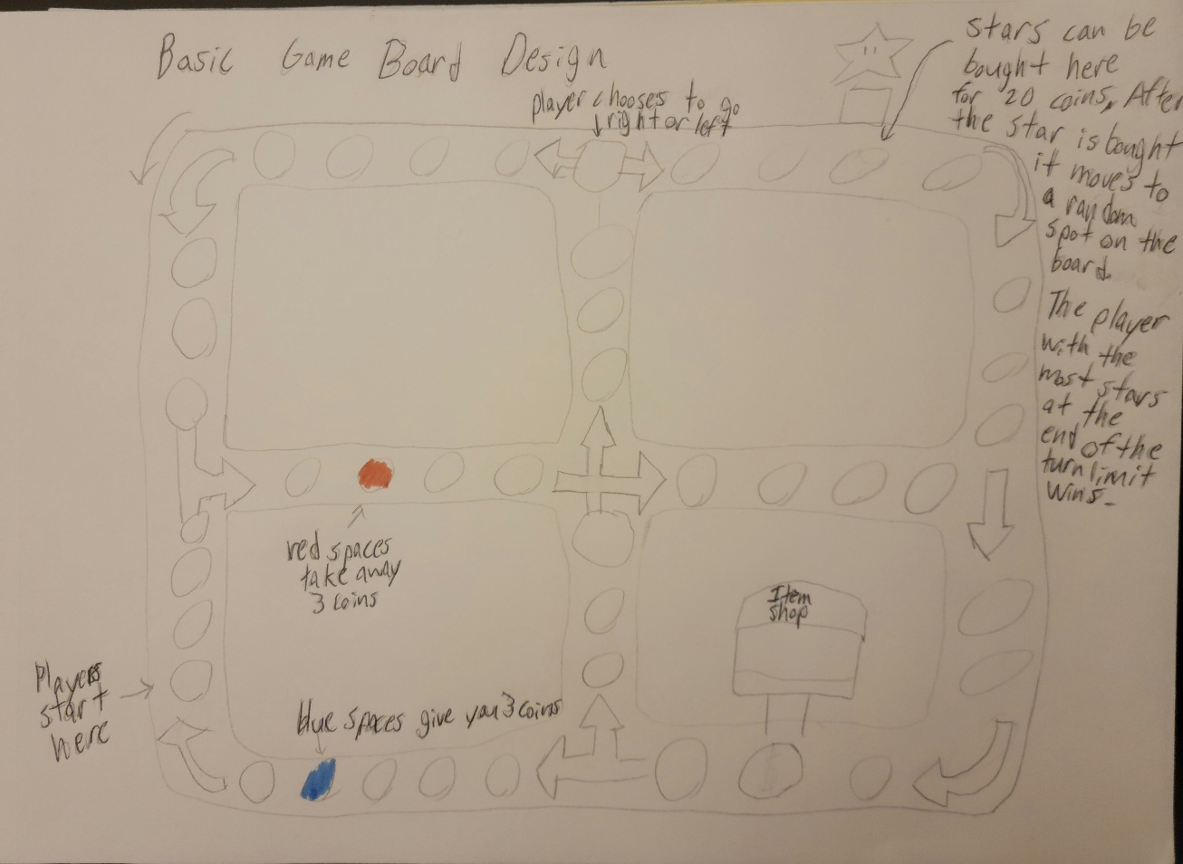

Online Board Game using HTML with PHP as a backend with SQL for database

The user can use a guest account or create an account that saves the results from previous games and friends list

**Home page**

* log in button
* register new user button
* guest login button
* instructions / FAQ for game rules

**When signed in:**

* start a game lobby button
* friends list

**Pre-game lobby page**

* show friends list on side of the screen with buttons for each to send an invite
* show link for the lobby with copy link button

**everyone can see the following but only the lobby leader can edit:**

* + number of turns to play to (15, 20, 25, …) showing estimated time for each number of turns

(if time permitted):

* + lobby leader can vote on a game board
  + lobby leader can choose the topics for trivia questions (ex: History, Sports, Math, Movies, etc.)

**Game Page**

* game board graphics
* each player’s game piece on the board
* button to roll dice when your turn starts
* each player’s number of coins
* bottom of the screen shows the 4 players name, color, and icons for the items in their inventory
* at the start of the game each player rolls a dice to see who moves first, the highest number goes first
* after each player has had a turn the players must answer a random trivia question. Whoever selects the correct answer first gets 4 coins, second gets 3 coins, third gets 2 coins, you get 0 for an incorrect answer.
* Coins can be spent at the shop for items that can help you
* Players can also spend 20 coins to buy a star
* After someone buys a star it moves to another space on the board
* The player with the most stars at the end of the game wins

Needs some kind of polling or pushing to update the game state

Data I need to store:

* Usernames
* Hashed Passwords
* Active game links
* The users in each game including registered users and guest accounts
* Player position on the board
* Each player’s inventory of items
* Each player’s number of coins
* Each player’s number of stars
* The results of each game including who won